**Assignment #2**

**Name: Muhammad Anas**

**Roll No: 21K-3437**

**Section: 3-G**

**Question**

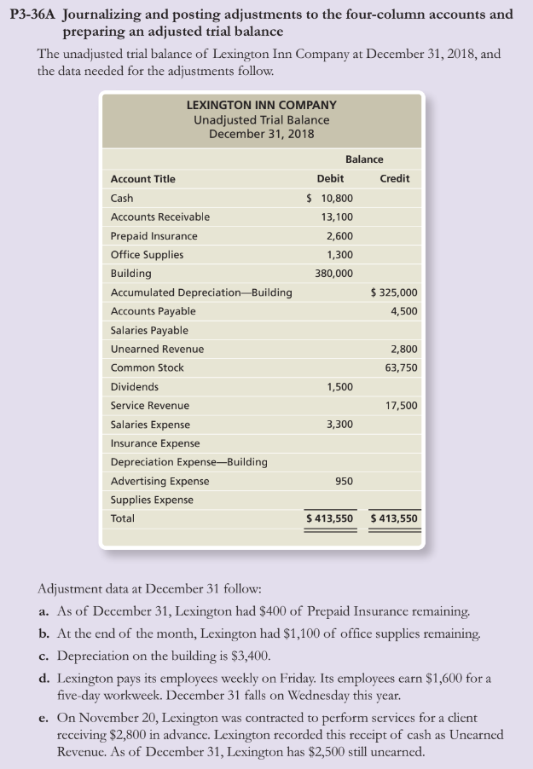

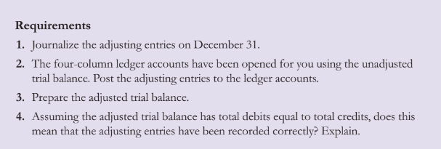

**1)**



**2)**



















**3)**



**4)**

No. Even if total debits equal total credits on the adjusted trial balance, this does not mean that the entries have been recorded correctly. The trial balance only shows the amount, it does not show whether the entry is correct or not.